

NAME – VAIBHAV KHARE

EMAIL ID – [VAIBHAV.KHARE96@GMAIL.COM](mailto:VAIBHAV.KHARE96@GMAIL.COM)

QUESTION 1 – Use ps to search for the “system” process by name.

Ans –

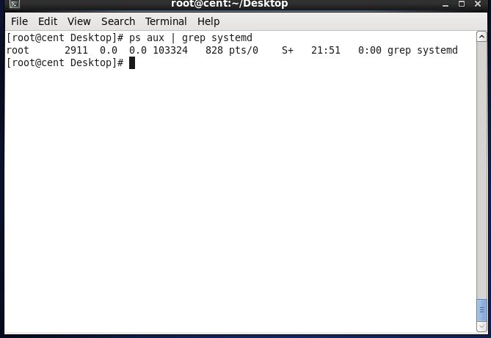

Question 2 – Find out your terminal name. Using your terminal name, use ps to find all processes associated with your terminal.

Ans –

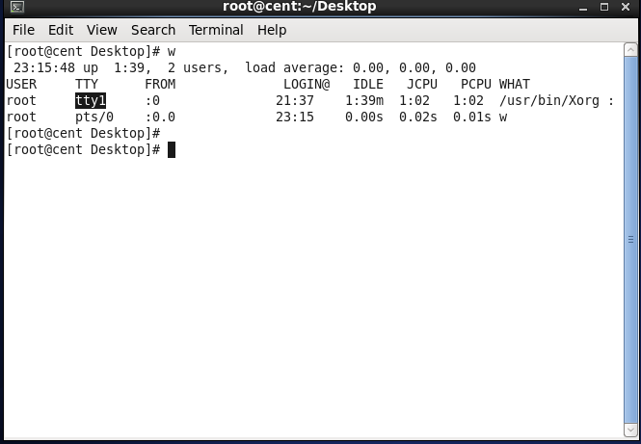

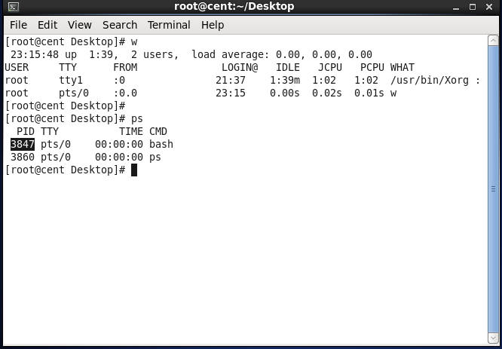

Question 3 – Check and note the process id of . your shell(from the output of the above command). . . Also note the parent process id of your shell.

Ans –



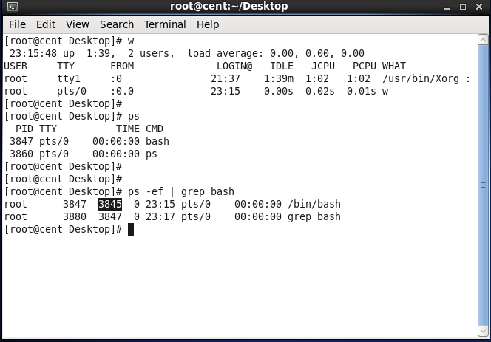

Question 4 – Start 3 instances of “sleep 123” as . background processes.

Ans –

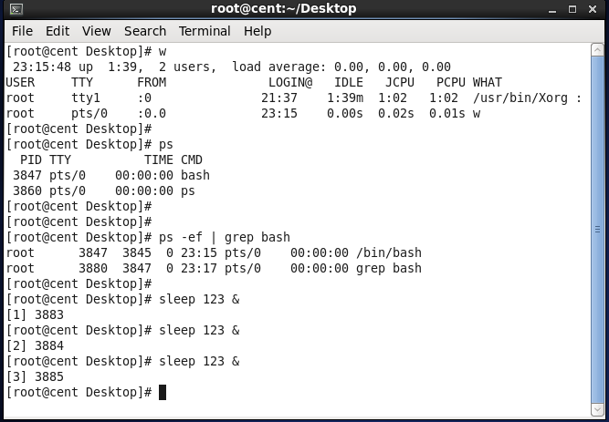

Question 5 – Check and note the process id’s . . of all sleep processes.

Ans –

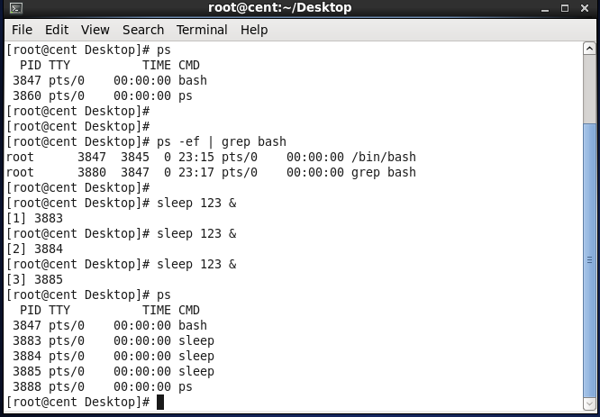

Question 6 – Display only those three sleep . . processes in top. Then quit top.

Ans –

